

Board Manufacturing Diagnostic

Revision 1.4
Wednesday
Wednesday, March 22, 2000

Copyright © 1996-2000 3Dfx Interactive, Inc. All Rights Reserved

3Dfx Interactive, Inc.
4435 Fortran Drive
San Jose, CA 95134
Phone: (408) 935-4400
Fax: (408) 262-8602
www.3dfx.com

1. Introduction 3
1.1 Test Station 3
2. Test Coverage Overview 4
3. Using the Software 7
3.1 Board MFG Diagnostic 7
3.1.1 MDC Tests 7
3.1.2 Golden File Generation 8
3.1.3 Non-Interactive Tests 9
3.1.4 Interactive Tests 10
3.1.5 Miscellaneous Command Line Switches 11
3.2 Fault Isolation 12
3.2.1 Error Codes 12
3.2.2 Example output of STDOUT.LOG 15
3.2.3 Error Summary Code 17
3.2.4 Standard Memory Error Summary 17
3.2.5 Usage Examples 17
Appendix A: Error Summary Table……………………………………………………………………17
Appendix b: VGA Core Error Codes ………………………………………………………………….……….18
appendix c: Specification Revision History.………………………………………………….….19

Introduction

This document explains the 3Dfx Board-Level Manufacturing Diagnostic to be used by any customer during board assembly or to validate board assembly and card functionality. The tool and this document are broken into two sections. The board manufacturing section covers issues relevant to using this tool to test for correct board assembly and functionality. The fault isolation section covers issues relevant to those debugging board assembly or functionality problems.

Test Station

A proper test station is required. This diagnostic should run on any Intel x86 compatible PC running under MS-DOS with at least 16MB of RAM. However, it is tested to run correctly only on genuine Intel Pentium and Pentium-II CPUs with at least 32MB of RAM. A single monitor is required. The program is designed to run under DOS only. It will not run correctly under any version of Windows. It will not run in a DOS box under Windows. In order to run it from Windows, go to the Start menu, choose "Shutdown", and then choose "Restart the computer in MS-DOS mode".

The Preferred Test Configuration:
Intel Pentium-II CPU
Intel Seattle Motherboard or similar, using Intel 440LX or 440BX chipset
At least 32MB RAM
Hard Drive
VGA Monitor

Test Coverage Overview

This section intends to provide an overview of the entire Voodoo4 testing process, with specific emphasis on how the board-level manufacturing house fits in. Here is a diagram of a Voodoo4 based video card:

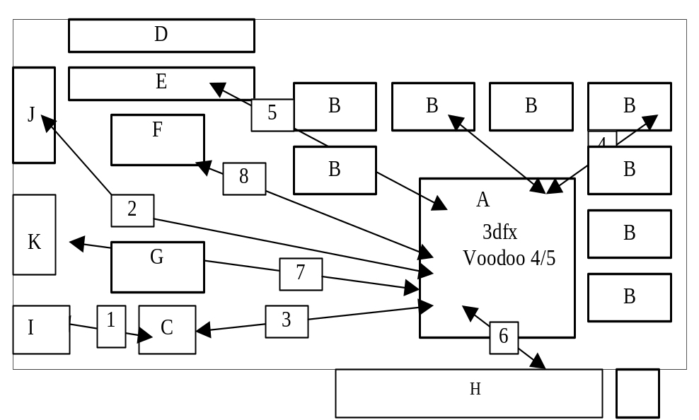

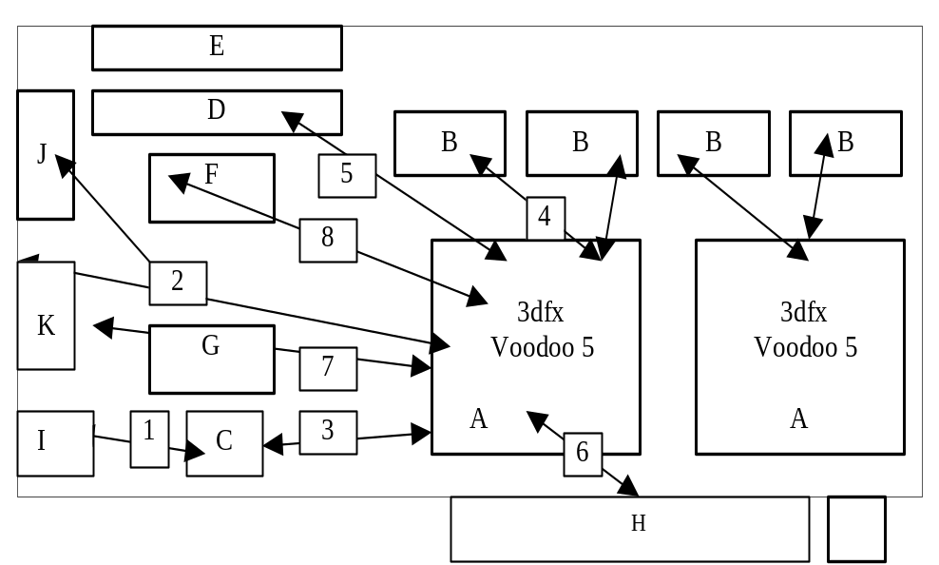

In the charts below, the coverage for different parts of the board is outlined. The more redundant testing we can provide, the better.

Parts |  | MDC Auto | MDC Visual | Pre-assembly Test By
A | Voodoo4/5 Chip |  |  | 3Dfx
B | DRAM (SG/SDRAM) |  |  | Chip Vendor
C | TV Encoder (optional) |  |  | Chip Vendor
D | VMI port Connector |  |  | N/A
E | Video Feature Connector |  |  | N/A
F | Flash EEPROM |  |  | Chip Vendor
G | DFP Transceiver |  |  | Part Vendor
H | AGP or PCI Connector |  |  | (none)
I | TV composite video output connector (optional) |  |  | Part Vendor
J | VGA Connector |  |  | Part Vendor
K | DFP Connector |  |  | Part Vendor

Connectivity |  | MDC Auto | MDC Visual | ICT
1 | TV Encoder  Composite Video connector |  |  | 
2 | Voodoo4 /55 VGA Connector |  |  | 
3 | Voodoo4 /5 TV Encoder (optional) |  |  | 
4 | Voodoo4/5  DRAM |  |  | 
5 | Voodoo4 /5 Video Feature/VMI Connectors |  |  | 
6 | Voodoo4/5  AGP/PCI bus |  |  | 
7 | Voodoo4 /5 Flash EEPROM |  |  | 
8 | Voodoo4 /5 Strapping Resistors (not pictured) |  |  | 

The Voodoo4 core is internally broken up into sections as well. The tests performed on chip internals are outlined below:

Section | Chip Vectors  @3Dfx | MDC Auto | MDC Visual
Legacy VGA |  | 
2D Accelerator |  | 
3D Accelerator |  | 
DRAM Interface |  | 
RAMDAC  (digital) |  | 
RAMDAC (analog) |   (dac linearity) |  |   (visual)

Using the Software

Board MFG Diagnostic
The primary goal of the Board MFG Diagnostic is to assure that the board was assembled correctly and that all the parts placed on the board are working correctly. It runs in a very short period of time, on the order of a few minutes. Its primary output to the user will be whether or not the board passed. At the manufacturing facility, this program is used along with the board in test as the only display adapter in the system. Users of this program do not need to be familiar with the technical aspects of the board to be tested.

The Board MFG Diagnostic is contained in the MDC.EXE executable. Along with the executable, there are a set of .3df files which contain texture data for the 3d texture mapped triangle tests, a set of data files for the unreal test, and a set of .lua files which contain script language code to run the tests. The directory structure for the diagnostic should have been installed like this:

MDC.EXE

LUA\INIT.LUA
LUA\<other lua script language files>
3DF\DECAL.3DF
3DF\<other 3df texture files>
UNREAL\<unreal test data files>
GLD\<framebuffer checksum files>

MDC Tests
The MDC diagnostic consists of two types of tests: non-interactive tests and interactive tests. The non-interactive tests run without any user input while the interactive tests require user input. The pass and fail status of the non-interactive tests is determined by comparing the results of each test with reference data stored in a file known as a “golden” file. This pass/fail status is stored in an output file (default name is “STDOUT.LOG”) that is automatically generated each time the test is run.
The tests can be run individually by using the appropriate command line argument or they can be run together by using the /all command line parameter. Below is a quick list of all of the tests along with the appropriate command line argument:

Non-Interactive Tests | Functionality Tested
/basic | PCI and memory test
/video | VGA video tests
/blit2d | 2D accelerator tests
/glide | 3D accelerator tests
/unreal | Unreal 3D render test
/ddc | Monitor display data channel test
/serialrom | Serial EPROM test (for TV out boards only)
/ssid | Subsystem device ID test
/svid | Subsystem vendor ID test
Interactive Tests | Functionality Tested
/vga | VGA mode test
/color | Red/Green/Blue color bar test
/ntsc,/pal,/palm  /palnc | NTSC or PAL TV out test
/lcd | LCD test
/crt | CRT test

Golden File Generation

Before the diagnostic can be used, a golden file must be generated. This file, named “GOLDEN.SUM”, contains reference data that a board is compared against to determine if it should pass or fail. Because all boards will be compared to this golden file, it is important to be sure this data is generated from a “good” board. Alternatively, this file can be provided to you by 3Dfx. Each different board layout/BOM should have it’s own golden file.

Examples

Here are some examples of using the command line parameters to generate a golden file:

Mdc /gengolden | Generates the golden file golden.sum which can be used to verify other boards with the same layout and options. This should only be run once and it should be run on a board known to be good (a 'golden' board).
Mdc /gengolden /unreal | The /unreal argument tells mdc to gather checksums for the unreal test. The unreal data files must be installed for this to work.
Mdc /gengolden /ddc | The /ddc argument tells mdc to gather checksums for the monitor ddc test.
Mdc /gengolden /unreal /ddc | Adding both tells mdc to gather checksums for both the unreal test and the ddc test

Non-Interactive Tests
The non-interactive tests are explained in more detail below:

Test | Functionality Tested
/basic |  | PCI tests (validate the PCI path to the graphics chip):  - Config space and I/O space read/write  - MMIO space read/write  RAM tests  - Returns memory size  - Full graphics DRAM test includes following  - Constant fill (writes 0, 0xAA55AA55, 0x55AA55AA values to memory)  - Alternate fill (writes 0x00000000, 0xFFFFFFFF, 0xAA55AA55, 0x55AA55AA values to memory)  - Random fill (writes random values to memory)  DesktopStart test (validates remapping of desktop by changing the desktopstart register)
/video |  | Tests VGA core functionality  Tests both standard VGA and VESA extended modes
/blit2d |  | 2D tests (exercise 2D portion of the graphics engine)  - Screen-to-Screen Blt /Screen-to-Screen Stretch Blt  - Rectangle Fill  - Polyline draw mode  - Line draw mode  - Polygon fill  - Hardware Cursor
/glide |  | 3D tests (exercise 3D portion of the graphics engine)  - Point test  - Line test  - Flat triangle test  - Shaded polys  - Textured /Textured trisetup
/ddc |  | Tests monitor DDC communication path. NOTE: This test reads information from the currently connected monitor; therefore, you must have a monitor connected to perform this test.
/unreal |  | Uses unreal test data to check 3d rendering functionality.
/vpd <num> |  | Automatically checks whether <num> is same as the assembly number stored in PCI Vital Product Data (VPD) area. This test also reads the serial number stored in VPD structure and saves this along with the assembly number in the STDOUT.LOG output file.  When using this command, start with the 4th digit of the assembly number.  Example: /vpd 0777008 Checks whether the assembly number is 110-0777-008
/svid <num> |  | Checks whether <num> is same as the PCI subsystem vendor ID.
/ssid <num> |  | Checks whether <num> is same as the PCI subsystem device ID.
/serialrom |  | Tests the serial EPROM which is used to store the board’s TV out default setting
/all | Runs all standard non-interactive tests except unreal and ddc

Extra Command-Line Switches for Non-Interactive Tests
There are some additional command-line switches which can be used to further modify how the non-interactive tests are run. These are explained below:

Command Line Switches | Functionality Tested
/sli | Performs RAM memory test on the slave device of SLI board.  MUST BE USED WITH THE /BASIC or /ALL TEST.
/cksm <val> | Used to compare the current BIOS checksum with a given value. <val> must be a hex number. If no value is given, then the checksum will be calculated for the current BIOS. Example: /cksm 1FD45600  MUST BE USED WITH THE /BASIC or /ALL TEST.
/allmode | Test all of the extended VESA video modes. If this command is not used, only one mode will be tested for each resolution.  MUST BE USED WITH THE /VIDEO TEST.

Examples of Non-Interactive Tests

Here are some examples of using the command line parameters to run non-interactive tests:

Command Line Switches | Functionality Tested
Mdc /all | Run all non-interactive tests on the current board. You must have a golden.sum file for this to pass a good board.
Mdc /basic | Run the basic PCI and framebuffer tests
Mdc /basic /cksm F35B00 | Run the basic tests and verify that BIOS checksum = F35B00.
Mdc /all /unreal /ddc /allmode | Run all non-interactive tests, the unreal test, the ddc test and test all extended VESA modes.

Interactive Tests

The interactive tests are explained in more detail below. After each test is performed, the user is asked to enter either a ‘Y’ if the screen looks okay or ‘N’ if there is a problem with the screen.

Test | Functionality Tested
/vga <mode> | Interactive RAMDAC test of a particular vga mode where <mode> must be a hex number. A set mode command is issued and a pattern is drawn on the screen. See table below for a list of valid vga modes.
/color | A red, green and blue color bar is displayed on the screen.
/ntsc,/pal,/palm,/paln/palnc | Tests TV out. If /comp switch added, then test composite TV out. Otherwise, default is to test svideo TV out.
/lcd | Test LCD display
/crt | Test CRT display. This can be used to return back to CRT after testing TV out or LCD display.

Table of Valid Modes for Voodoo4/5:
Listed below are the extended modes for use in /vga mode test:

Resolution | 4bpp | 8bpp | 16bpp | 24bpp
640x480 | 12 | 101 | 111 | 112
800x600 | 102 | 103 | 114 | 115
1024x768 | N/A | 105 | 117 | 118
1280x1024 | N/A | 107 | 11A | 11B

NOTE: All mode numbers are presented in this table in hex (base 16) form. This is how they should be presented to the /vga command line argument.

Examples of Interactive Tests

Here are some examples of using the command line parameters to run interactive tests:

Command Line Switches | Functionality Tested
Mdc /vga 11B | Run the interactive vga mode test using vga mode 11B (283). At end of test, a prompt will be displayed to press a key to confirm the screen correctness for the vga test.
Mdc /all /unreal /ddc /color | Run all non-interactive tests, the unreal test, the ddc test, and the interactive color bar test.

Miscellaneous Command Line Switches

There are other command line switches which can be used with either the interactive or non-interactive tests. These are listed below:

Test | Functionality Tested
/nopass | No PASS banner will be displayed at the end of the test if no errors occurred.
/fullmem | full memory error information will be recorded and reported to stdout.log. This will increase the time it takes to run the framebuffer tests. This must be used in conjunction with a test command line switch such as /basic or /all.
/cont | Continue on error. By default, the test will stop after the first error.
/rep <num> | Controls the number of times to repeat the test where <num> is number of times to repeat the test.
/log <path\new.log> | Changes the path and name of the output file. Default name is STDOUT.LOG.
/comp | Used to test composite TV out. If not added, then all TV out tests default to svideo TV out.
/debug | Displays the pass/fail status of all tests run.

Fault Isolation

MDC stores information each time it is run in an output file. The primary goal of this file is to help isolate and identify board level failures. Users of this part of the program's functionality should be familiar with board manufacturing, manufacturing problems, and high level functionality of DRAM and graphics chips in general.

To see the fault isolation log, run any test, and then view the file stdout.log with a DOS command such as type or more. For example, type "more stdout.log" after running a given test. To increase the amount of information reported, use either the /fullmem or /cont switches.

Error Codes
Below is a chart of the tests performed, their error codes, a description of what the test does, and common fault causes. The letters and numbers next to faults indicate sections of the board as described in the Test Coverage Overview in Section 2.

Module/Test  Error Code | Description | Fault Causes
PCI/main  Error Code: 2 | PCI bus test, a sequence is written and read back across the PCI bus using a scratch register to validate that the PCI bus pins are working correctly. | - Defects in solder connections to Voodoo4 PCI bus pins (6)  - Defects in the PCI bus traces (H)
Fbi/memsize  Error Code: 4 | The correct amount of memory was detected. Detection is done via strapping pins. Possible configurations are: 8MB SGRAM, 16MB SGRAM, 16MB SDRAM. | - Incorrect strapping resistors (G)  - Defects in solder connections to Voodoo4 strapping pins (8)
Fbi/memory  Error Code: 5 | The framebuffer memory test passed. A sequence is written and readback across the entire frame buffer memory. | - Defects in solder connections to Voodoo4 DRAM bus pins (4)  - Incorrect DRAM timings  - Defects in DRAM traces (4)  - Defects in DRAM chips (B)
Fbi/slave memory  Error Code: 36 | The framebuffer memory test on the slave device of an SLI board passed. A sequence is written and readback across the entire frame buffer memory. | - Defects in solder connections to Voodoo4 DRAM bus pins (4)  - Incorrect DRAM timings  - Defects in DRAM traces (4)  - Defects in DRAM chips (B)
BIOS/main  Error Code: 6 | The BIOS checksum test passed. The sum of all bytes in the BIOS = expected value. | - Incorrect BIOS EPROM.  - Defects in BIOS EPROM (F) (7)
BIOS/main  Error Code: 7 | The BIOS vital product data structure test passed. The correct assembly number and serial number was found in the VPD. | - Incorrect BIOS EPROM.  - Defects in BIOS EPROM (F) (7)
BIOS/main  Error Code: 30 | The Serial EPROM test passed. The correct TV out setting can be safely read from the serial EPROM. | - Only installed on boards supporting TV out.  - Defects in Serial EPROM chip
Vga/core  Error Code: 31 | VGA core test failure (see Appendix B for more details) | - Problems with Voodoo4 vga core  - Uses: PCI, DRAM, vga core
Vga/mode_0xhhh  Error Code: 9 | Hhh is the mode number | - Incorrect BIOS EPROM  - Defects in BIOS EPROM (F) (7)  - Problems with Voodoo4 vga core  - Uses: PCI, DRAM, vga core
Vga/ext_mode_0xhhh  Error Code: 8 | hhh is the extended vga mode number | - Incorrect BIOS EPROM  - Defects in BIOS EPROM (F) (7)  - Problems with Voodoo4 vga core  - Uses: PCI, DRAM, vga core
b2d/hwcursor_x_y  Error Code: 10 | x and y are the locations where the hardware cursor is placed | - Uses: PCI, DRAM, 2d core  - Problems with Voodoo4 2d core
b2d/flat_rectn  Error Code: 11 | n is the frame number of the flat rectangle test | - Uses: PCI, DRAM, 2d core  - Problems with Voodoo4 2d core
b2d/hw_overlay_bilinear  Error Code: 12 | Hardware Video Overlay bilinear filter test. | - Voodoo4 internal chip functionality.
b2d/desktopstart_reg  Error Code: 24 | Windows physical desktop starting address test. | - Voodoo4 internal chip functionality.
b2d/stos  Error Code: 35 | 2D BitBlit test. | - Problems with Voodoo4 2d core.
3d/point_test  Error Code: 14 | 3d points are drawn in a line | - Uses: PCI, DRAM, 3d core  - Problems with Voodoo4 3d core
3d/line_test  Error Code: 15 | 3d lines are drawn in an overlapping pattern | - Uses: PCI, DRAM, 3d core  - Problems with Voodoo4 3d core
3d/tri_test  Error Code: 13 | a triangle is drawn with a flat color | - Uses: PCI, DRAM, 3d core  - Problems with Voodoo4 3d core
3d/shaded_tri_test  Error Code: 16 | a triangle is drawn with gouraud shading | - Uses: PCI, DRAM, 3d core  - Problems with Voodoo4 3d core
3d/tex_tri_test  Error Code: 17 | a textured triangle is drawn | - DRAM Timing Problem  - Problems with Voodoo4 3d core  - Uses: PCI, DRAM, 3d core
3d/splash_frm  Error Code: 18 | n is the frame number of the 3Dfx splash screen. The entire splash screen is played back and each frame is checked. The splash involves most triangle parameters including: shading, textures, alpha, and mip-mapping. | - DRAM Timing Problem  - Problems with Voodoo4 3d core  - Uses: PCI, DRAM, 3d core
Video/DAC_check  Error Code: 21 | This is the visual DAC_check. A test screen is shown, and the operator validates its correctness. | - Connectivity Problem to VGA connector (2)(J)
Video/color  Error Code: 22 | This is manual video color bar test | - VGA RGB color connectivity.
3d/unreal_test  Error Code: 19 | Unreal test files not correctly installed. | - Be sure unreal data files are correctly installed.  - Be sure gld subdirectory is installed.
3d/unreal_frm  Error Code: 20 | Unreal test frame failed pixel consistency check. | - Voodoo4 internal chip functionality.
TV/ntsc  Error Code: 26 | NTSC TV out problem. | - Be sure proper cable connected.  - Be sure board supports TV out.
TV/pal  Error Code: 27 | PAL TV out problem. | - Be sure proper cable connected.  - Be sure the board supports TV out.  - Make sure BIOS supports TV out.  - Brooktree 869 functionality.
TV/lcd  Error Code: 28 | LCD problem. | - Be sure proper cable connected.  - Be sure board supports LCD.  - Make sure BIOS supports LCD.  - LCD chip functionality.
TV/crt  Error Code: 29 | CRT problem. | - Be sure proper cable connected.
ddc/data  Error Code: 23 | DDC monitor communication test. | - VGA connector /DDC pin connectivity problem

Example output of STDOUT.LOG
Here is example output from 'mdc /all'. Repetitive lines have been removed and replaced with the marker [...]. Comments are in bold on the right side.
*******************************************************************
*** 3dfx Board Manufacturing Diagnostic ***
*******************************************************************
*************************************
**** Board Startup ****
*************************************

Default Board Selected bus:1 slot:0
default board initialized

**** ROM Check ****
ROM checksums compare okay (passed).
BIOS Version: Version 1.00-SG

Serial EPROM test passed.
**** ROM VPD Check ****
Assembly numbers matched (passed).

**** Basic Tests ****

PCI scratch test passed

PCI Subsystem Vendor ID check passed.

PCI Subsystem ID check passed.

Voodoo4 mmio linear: 0xFC000000 (mapped)
dramInit0 = 0x08169D25 dramInit1 = 0x4024C030
old lfbMode = 0x00000000
old lfbMemoryConfig = 0x00003FFF
Detected 8 MB of SDRAM
Voodoo4 mmio linear: 0xFC000000 (mapped)
dramInit0 = 0x08169D25 dramInit1 = 0x4024C031
old lfbMode = 0x00000000
old lfbMemoryConfig = 0x00003FFF
Detected 8 MB of SDRAM
Voodoo4FbiTest linear: 0xF0000000 (mapped)
const_fill(0x00000000): 0 errors ← no const_fill memory errors
const_fill(0xAA55AA55): 0 errors
const_fill(0x55AA55AA): 0 errors
start = 0xF0000000, end = 0xF0800000
rndm_fill(): 0 errors ← no random fill memory errors

**** Video Tests ****

calling ediag, args: argv[0] = '(exepath)' argv[1] = '-T=VGAMODE'
checksum 'vga3' failed (ex=0x9CD9ffff,rec=0x9CD9DD1C)← vga mode 3 test failed
[...]

**** Blit2d Tests ****

2d blit test

**** Glide (3d) Tests ****

checksum 'tex_tri_test' failed (ex=0x1DA7ffff,rec=0x1DA7A091)
← texture test failed

checksum 'splash_frm46' failed (ex=0x2A63ffff,rec=0x2A63D984)
← splash test frame 46 failed

********************************************
**** Final Output Summary ****
********************************************
Module Test Pass Fail
3d splash_frm46 pass:0 fail:1

Error Summary Code: 18

###### ## # # ###### #####
# # # # # # # #
##### # # # # ##### # #
# ###### # # # # #
# # # # # # # #
# # # # ###### ###### #####

3dfx Voodoo4 Test Completed
PCI Config VID = 0x121A, DEVID = 0x5
PCI Config SVID = 0x34121A, SSID = 0x34
dramInit0 = 0x0C5FAE29 dramInit1 = 0x0054C031
Memory Size = 16MB
Pllctrl1 register = 0x3A05
Memory Clock = 143 Mhz
Assembly Part Number = 1100777008
Serial Number of Board = 1234567ABCD890EFGH
BIOS: Version 1.00-SG
BIOS Checksum: 0x2DBA00
[ 3Dfx mfgdiag version N_x, build on Mar 16 2000 20:02:19 ]
see STDOUT.LOG for the full test output
Exit Code: 18

Error Summary Code

The error summary code is listed just before the FAILED banner.

Standard Memory Error Summary

If the framebuffer memory check fails, there will be a summary printed to STDOUT.LOG. The type and location of the failure can be determined by investigation of the summary output. There are three types of tests that occur on the framebuffer memory. Along side the test type in the following table is listed the possible/likely failure causes. These are not the only failure causes. For example, a missing or bad dram chip, or a bad address line, can cause failures in all of the tests. One should consult the bank and word summaries explained below for additional information.

test type | Possible/Likely Failure Causes
const_fill(0x00000000) | Bad databit, bad address connection
alternate_fill(0x00000000,0xFFFFFFFF) | Solder or trace failure, databit unconnected
alternate_fill(0xFFFFFFFF,0x00000000) | Solder or trace failure, databit unconnected
const_fill(0xAA55AA55) | databit bridge, check solder connections at DRAM chip
const_fill(0x55AA55AA) | databit bridge, check solder connections at DRAM chip
alternate_fill(0xAA55AA55,0x55AA55AA) | solder or trace failure on data or address bit, address bit not connected at memory chip
alternate_fill(0x55AA55AA,0xAA55AA55) | solder or trace failure on data or address bit, address bit not connected at memory chip
rndm_fill()  const_fill(0x00000000): 0 errors  alternate_fill(0x00000000,0xFFFFFFFF): 0 errors  alternate_fill(0xFFFFFFFF,0x00000000): 0 errors  const_fill(0xAA55AA55): 0 errors  const_fill(0x55AA55AA): 0 errors  alternate_fill(0xAA55AA55,0x55AA55AA): 0 errors  alternate_fill(0x55AA55AA,0xAA55AA55): 0 errors  start = 0xF0000000, end = 0xF1000000  rndm_fill(): 262155 errors | databit or address line problem

Here is an example of how you will see these test types listed in the STDOUT.LOG. If one of these tests fails, you will see an error summary immediately below the test. The next section describes how to interpret the error summary.

Usage Examples

Here are some examples of using the command line parameters:

mdc /basic /fullmem | runs the PCI and framebuffer tests will full memory error reporting. The full results will be put in the STDOUT.LOG file.
mdc /all /fullmem | perform full memory error reporting, and then run all other non-interactive tests

Appendix A: Error Summary Table

Error Code | Description
2 | PCI register test failed.
3 | PCI configuration register test failed.
4 | Frame buffer memory size test failed.
5 | Frame buffer memory test failed.
6 | BIOS checksum test failed.
7 | BIOS VPD (vital product data) test failed.
8 | Extended VGA Mode test failed.
9 | Standard VGA Mode test failed.
10 | Hardware cursor test failed.
11 | Flat rectangle test failed.
12 | Hardware video overlay bilinear filter test failed
13 | 3D triangle test failed
14 | 3D point test failed.
15 | 3D line test failed
16 | 3D triangle with gouraud shading test failed
17 | 3D textured triangle test failed
18 | 3Dfx splash screen test failed.
19 | Unreal test files not correctly installed.
20 | Unreal test frame failed pixel consistency check.
21 | Visual DAC_check failed.
22 | Video color bar test failed.
23 | DDC monitor communication test.
24 | Windows physical desktop starting address register test failed
25 | AGP 2x test failed.
26 | NTSC TV out problem.
27 | PAL TV out problem.
28 | LCD display problem.
29 | CRT problem.
30 | Serial EPROM test failed. (TV out boards only)
31 | VGA core test failed.
32 | ConstantFill Memory test failed.
33 | RandomFill Memory test failed.
34 | AlternateFill Memory test failed.
35 | 2D BitBLT test failed.
36 | Frame buffer memory test on slave device failed.

appendix b: VGA Core Error Codes
When a VGA Core error occurs (error code 31), the following message will be recorded in the Video Tests section of the STDOUT.LOG file.

("error #= %x part=1 test=# addr=xxx index=xxx exp= xxx act=xxx " )

Below is an explanation of how to interpret this error message:

Error definitions error #
------------------------------------------------------------------------
No error occurred 0
Unexpected behavior 2
I/O Failure 3
Capture buffer didn't match 4
Incorrect or no frame rate 5
Test couldn't complete (malloc failure, etc.) 6
Video memory failure 7
Video data failure 8
Wrong dot clock frequency 9
Checksum error 11
File open/read/write/close error 12

part # (always = 1)

Test Definitions test# Test Definitions test#

UndocLightpenTest 1
UndocLatchTest 2
UndocATCToggleTest 3
UndocATCIndexTest 4
IOTest 5
CRTCAddressTest 6
IORWTest 7
ShiftRegisterModeTest 8
RandomAccessTest 9
ColorPlaneEnableTest 10
PixelWidthTest 11
CGAHerculesTest 12
ByteModeTest 13
HiResMono2Test 14
HiResMono1Test 15
PaletteAddressSourceTest 16
HiResColor1Test 17
LargeCharTest 18
LineCharTest 19
GraphicsModeBlinkTest 20
V67Test 21
V54Test 22
SyncPolarityTest 23
CursorLocationTest 24
CursorTypeTest 25
LimitedSetupTest 26
Text64KTest 27
OverscanTest 28
VideoStatusTest 29
CRTCWriteProtectTest 30
Ext512CharSetTest 31
Std256CharSetTest 32
ModeXTest 33
CursorDisableTest 34
CountBy4Test 35
Panning256Test 36
CursorSkewTest 37
SkewTest 38
Vload2Vload4Test 39
DoubleScanTest 40
SwitchReadbackTest 41
SyncPulseTimingTest 42
BlinkVsIntensityTest 43
TextModeSkewTest 44

appendix c: Specification Revision History
revision 0.1:
- First version
revision 0.2:
- Revised into documentation of existing MDC functionality
revision 0.3:
- Revised to include latest MDC version (B_4)
revision 0.4:
- Revised to include latest MDC version (B_5)
revision 0.5:
- Revised to Include latest MDC version (B_7)
- arguments added: /unreal, /ddc
- unreal datafile installation
- updated error codes
revision 0.6:
- Revised to Include latest MDC version (B_11)
- Changed references to Banshee to Voodoo4
- Changed numbering for error codes
- Updated output from STDOUT.LOG file

revision 0.7:
- Revised to Include latest MDC version (B_14)
- Arguments added: /vpd, /svid, /ssid
- Updated output from STDOUT.LOG file
- Deleted section on setting clock.

revision 0.8:
- Revised to Include latest MDC version (VD3_1)
- Arguments added: /ntsc, /pal, /palm, /paln, /palnc, /lcd, /crt, /allmode, /nopass,
/cksm, & /serialrom
- Updated output from STDOUT.LOG file

revision 1.0:
- Added /log argument
.
revision 1.1:
- Revised document to better explain differences in tests vs. switches.
- Corrected problem with VGA mode table.
- Added /agp switch.
- Added /vga core test

revision 1.2:
- Added error codes 32-35.

revision 1.3:
- Updated for Voodoo4.

revision 1.4:
- Added /sli argument for memory test of slave device.

